Symmetries of a Triangle
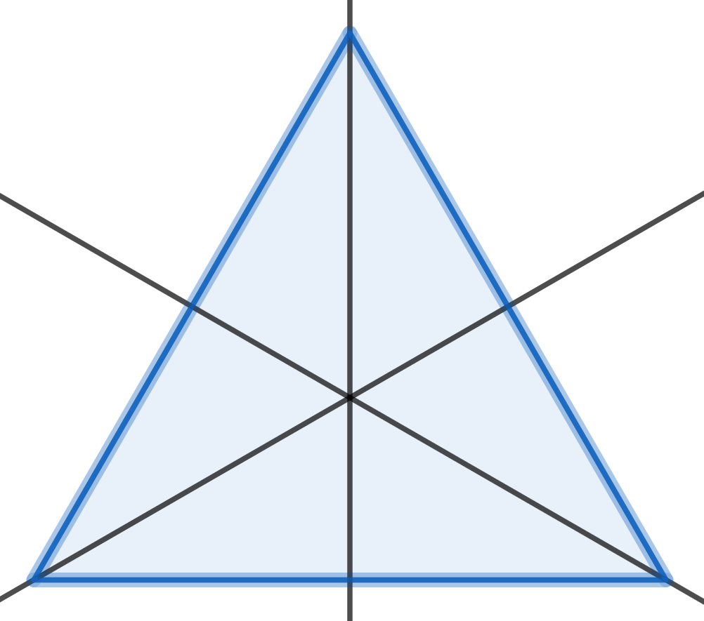

The symmetries of the equilateral triangle are:
do nothing
rotate 120° about the centre (anticlockwise)
rotate 240° about the centre (anticlockwise)
rotate 180° about the line through the bottom left-hand corner
rotate 180° about the line through the bottom right-hand corner
rotate 180° about the line through the top corner
We can combine symmetries.
means you doand then you doThis means you dofirst.
Take a piece of card, in the shape of an equilateral triangle.
If you doand then doit will end up in the same position as if you had just done
Try it.
Sois the same asSo
Show thatSoandare not the same.
* is not commutative.
Here is the combination table. You should check some of these.

* | e | p | q | r | a | b
e | e | p | q | r | a | b
p | p | e | a | b | q | r
q | q | b | e | a | r | p
r | r | a | b | e | p | q
a | a | r | p | q | b | e
b | b | q | r | p | e | a

Notegoes in therow and thecolumn.
Andgoes in therow and thecolumn.

The setwith the binary operation * forms a group.

